**PYTHON SOFTWARE**

|  |  |
| --- | --- |
| Date | 19 September 2022 |
| Team ID | IBM-Project-PNT2022TMID41904 |
| Project Name | IoT Based Safety Gadget for Child Safety  Monitoring & Notification |

STEP-1

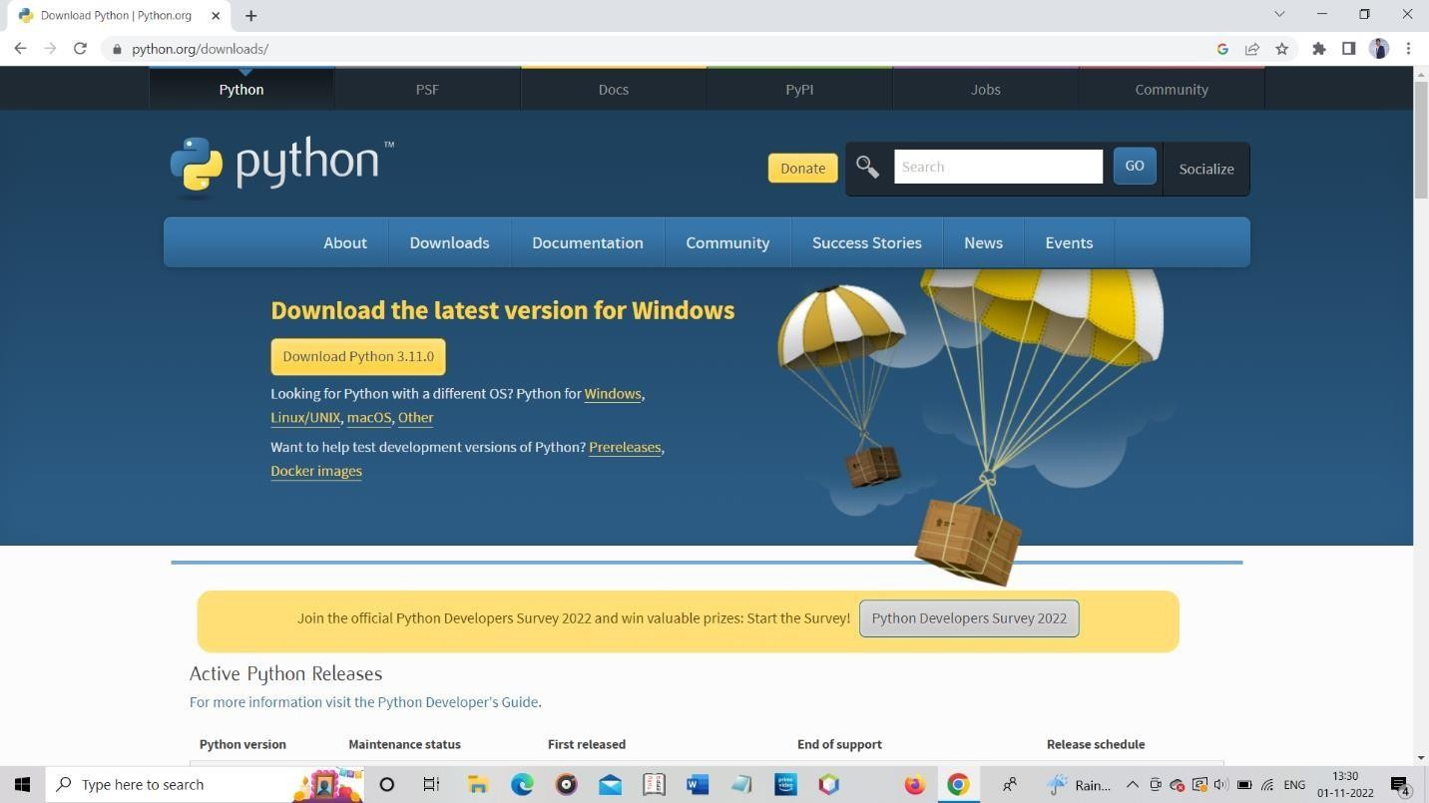

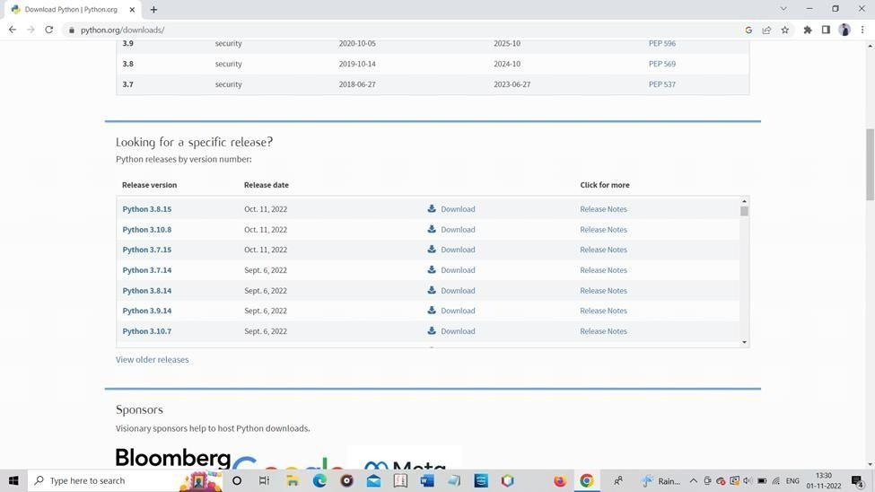

STEP-3

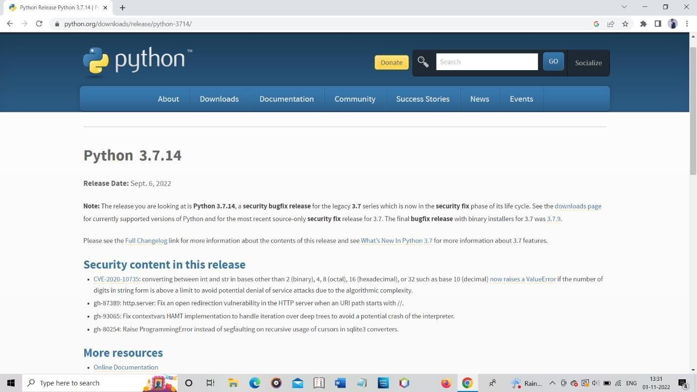

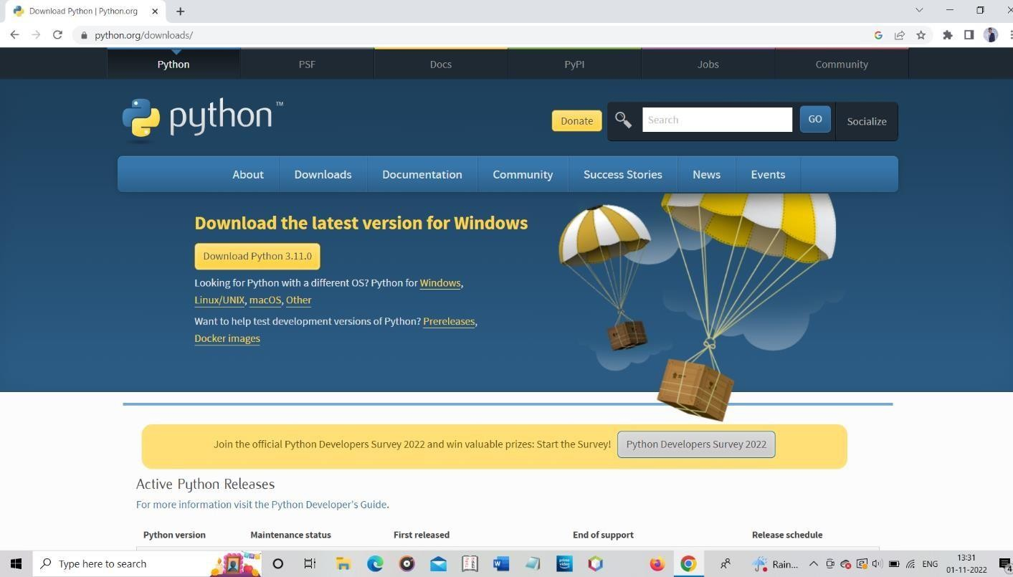

STEP-5

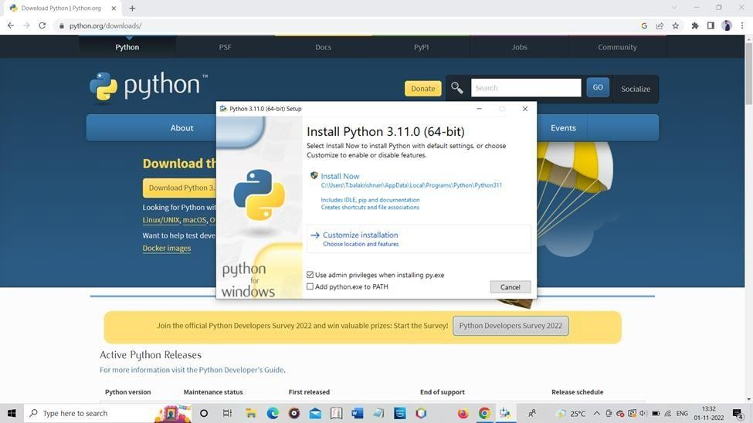

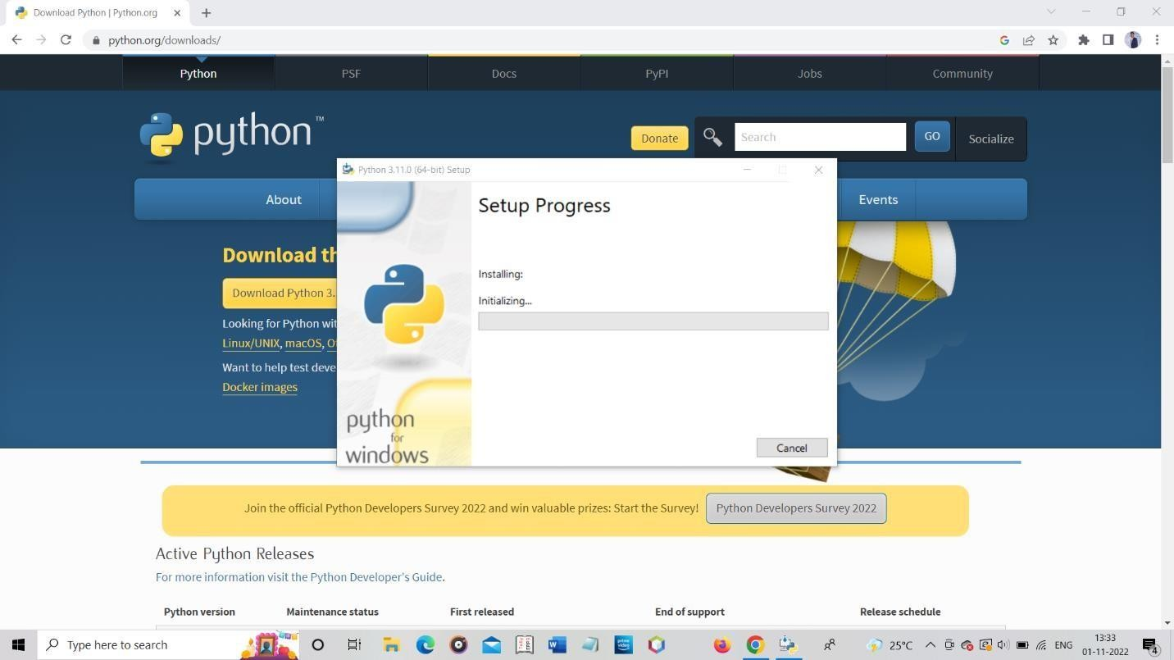

STEP-7

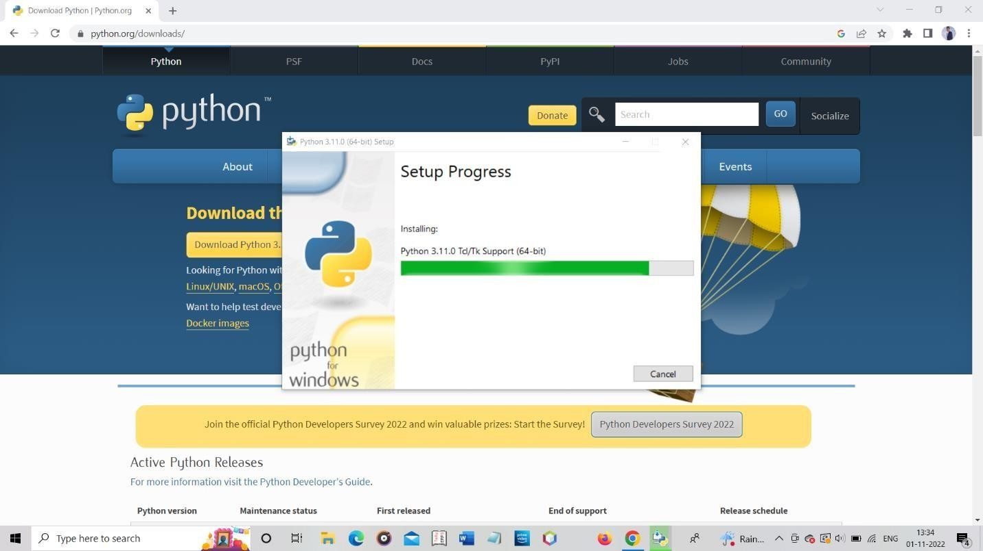

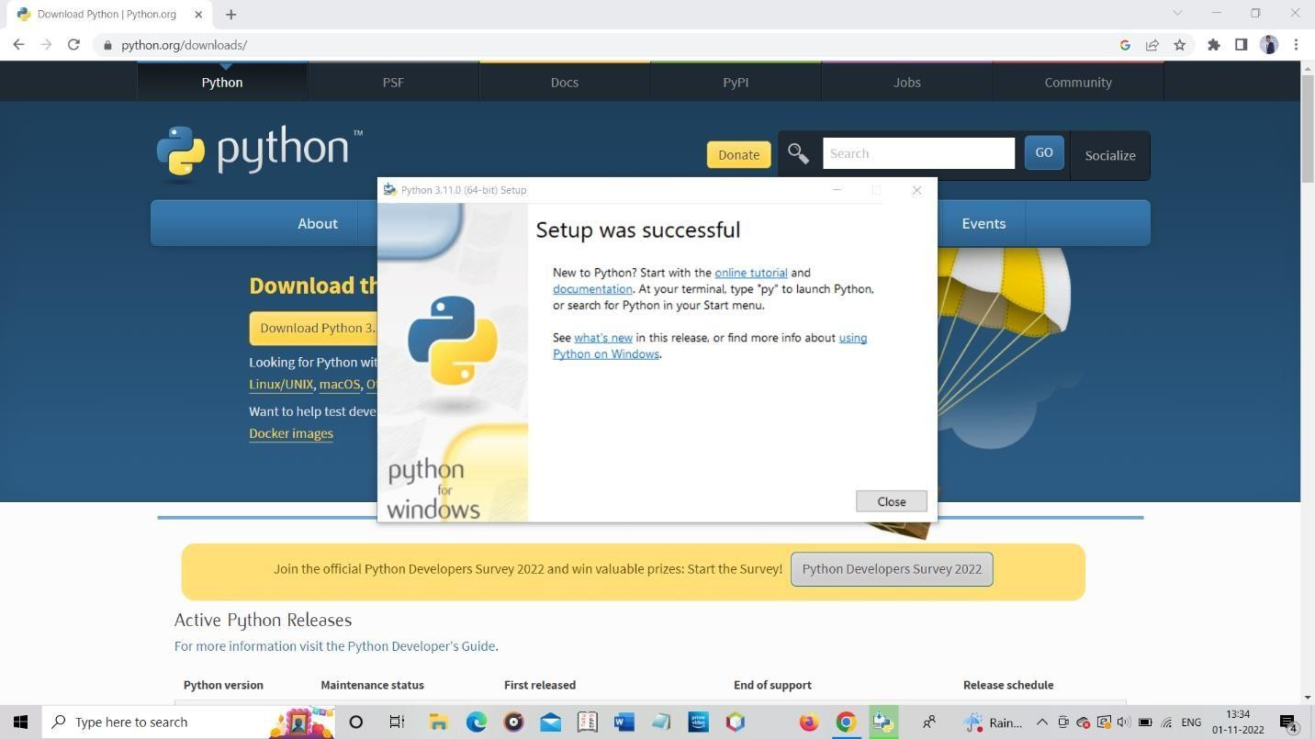

PYTHON CODE:

import json

import wiotp.sdk.device import time

myConfig = { "identity":{

"orgId": "hj5fmy",

"typeId": "NodeMCU", "deviceId":"12345"

},

"auth": {

"token": "12345678"

}

}

client = wiotp.sdk.device.DeviceClient(config=myConfig, logHandlers=None) client. connect ()

while True:

name ="smart bridge" #in area location #latitude=17.4219272 #longitude=78.5488783 #out area location latitude=17.4219272

longitude=78.5488783 myData= {'name':name,'lat’: latitude, ‘log’: longitude} client. publish Event (event ID="status”, msgFormat="json",

data=myData, qos=0, on publish=None)

print ("Data published to IBM IOT platform: “myData) time. Sleep (5)

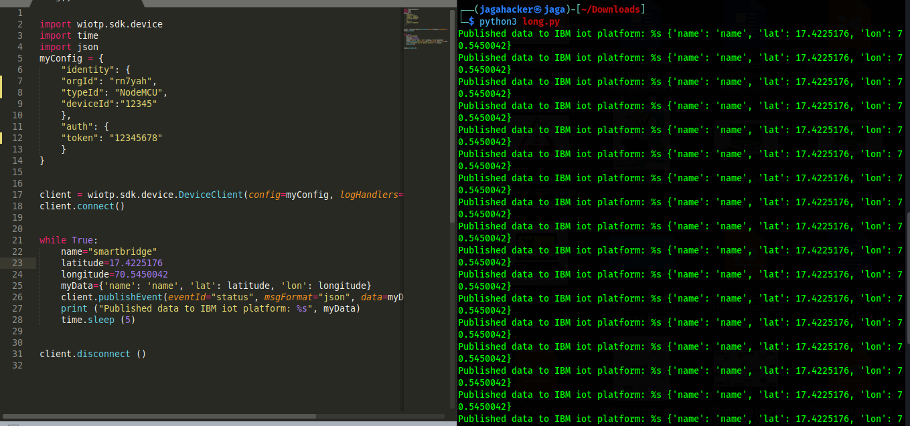

import wiotp.sdk.device

import time

import json

myConfig = {

    "identity": {

    "orgId": "rn7yah",

    "typeId": "NodeMCU",

    "deviceId":"12345"

    },

    "auth": {

    "token": "12345678"

    }

}

client = wiotp.sdk.device.DeviceClient(config=myConfig, logHandlers=None)

client.connect()

while True:

    name="smartbridge"

    latitude=17.4225176

    longitude=70.5450042

    myData={'name': 'name', 'lat': latitude, 'lon': longitude}

    client.publishEvent(eventId="status", msgFormat="json", data=myData, qos=0, onPublish=None)

    print ("Published data to IBM iot platform: %s", myData)

    time.sleep (5)

client.disconnect ()

